GPT NLP Lab Assistant Group 3
Muhammed Faseeh, Michael Fritzer
David Haybarger, Kevin Lee

Concept of Operations

Concept of Operations
for
GPT NLP Lab Assistant Group 3

Team AURA

Approved by:

Michael Fritzer 12/06/2025
_____________________________
Project Leader Date

Byung-Jun Yoon 12/06/2025
_____________________________
Professor Date

Fahrettin Ay 12/06/2025
_____________________________
T/A Date

Change Record
Rev. | Date | Originator | Approvals | Description
1 | 09/12/2025 | Michael Fritzer,  Muhammed Faseeh,  David Haybarger,  Kevin Lee | Michael Fritzer,Fahrettin Ay,Byung-Jun Yoon | Created initial ConOps.
2 | 10/03/2025 | Michael Fritzer,  Muhammed Faseeh,  David Haybarger,  Kevin Lee | Michael Fritzer,Fahrettin Ay,Byung-Jun Yoon | Updated ConOps per feedback given by Fahrettin.
3 | 12/06/2025 | Michael Fritzer,  Muhammed Faseeh,  David Haybarger,  Kevin Lee | Michael Fritzer,Fahrettin Ay,Byung-Jun Yoon | Final Release

Table of Contents
Table of Contents .............................................................................................................. Ⅲ
List of Tables ..................................................................................................................... Ⅳ
List of Figures .................................................................................................................... Ⅴ
1. Executive Summary ..……………………………………………………………………….. 1
2. Introduction ……………………………………………………………………….………….. 2
2.1. Background ………………………………………………………………………………. 2
2.2. Overview ……………..…………………………………………………………………… 2
2.3. Referenced Documents and Standards ………………………………………………. 3
3. Operating Concept …………………………………………...……………………………... 5
3.1. Scope ……………………………………………………..………………………………. 5
3.2. Operational Description and Constraints ……………………………………………… 5
3.3. System Description ……………….……………………………………………………... 6
3.4. Modes of Operations ……………………………………………………………………. 6
3.5. Users ………………………………..…………………………………………………….. 7
3.6. Support .……………………………..………………...………………………………….. 8
4. Scenario(s) ………………………………..………………………………………………….. 9
4.1. Lab Safety and Equipment Setup …………………………………...…………………. 9
4.2. Assisting with Research Lab Documentation and Data Review ………….………… 9
4.3. Preparing for a Lab Practical Exam ………………..….……………………………… 10
4.4. Checking Component Values Before Use …………………………….……………… 10
5. Analysis ……………………………...………………………………………………………. 11
5.1. Summary of Proposed Improvements ………………...……………………………… 11
5.2. Disadvantages and Limitations ……………………………………………………….. 11
5.3. Alternatives ……………………….……………………………………………………... 11
5.4. Impact ……………………………………………………………………………………. 12

List of Tables
TABLE 1: Modes of Operation for the AURA System ........................................................... 7
TABLE 2: User Groups Supported by the AURA System ..................................................... 7
TABLE 3: Table of Pros and Cons ....................................................................................... 11

List of Figures
FIGURE 1: System Diagram of The Autonomous University Robot Assistant (AURA) ........ 1
FIGURE 2: Organized operational flow diagram for the AURA system ................................ 3

Executive Summary
The Autonomous University Robot Assistant (AURA) is an AI powered laboratory assistant designed to improve learning efficiency and reduce instructional workload in university teaching and research labs. Built on the NVIDIA Jetson Orin Nano with an integrated camera, microphone, and touchscreen interface, AURA combines natural language processing, computer vision, and voice interaction to answer lab questions, reference documentation, and assist with troubleshooting.
AURA provides several important benefits including reducing dependency on teaching assistants for routine questions, providing instant access to reliable information, and reinforcing lab safety. The system uses retrieval augmented generation (RAG) over curated manuals, standard operating procedures (SOPs), and course material to ensure responses are accurate and based on approved sources.
To support instructors and maintain transparency, AURA logs interactions for later review and supports multimodal input including voice, text, and image. The system consists of multiple subsystems including power, computing, communication, control, and user interface that work together to deliver real time assistance. A high level overview of these subsystem interconnections is shown in Figure 1, which illustrates the flow of data and control throughout the system.
Deliverables include a fully assembled assistant, an integrated AI backend, a robotics subsystem, and a user-friendly interface for interaction and data review.
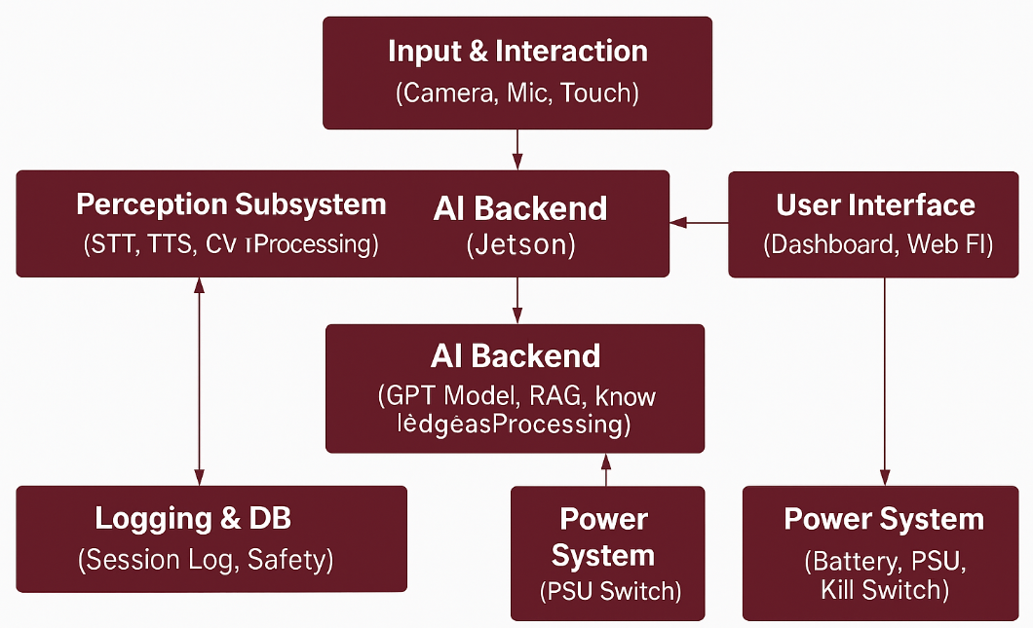
Figure 1: System Diagram of The Autonomous University Robot Assistant (AURA)

Introduction
The AURA project aims to design and implement an AI powered laboratory assistant that enhances instruction and supports student learning in university lab environments. The system integrates natural language processing, computer vision, and robotics to answer student questions, guide users through laboratory procedures, reinforce safety practices, and provide immediate access to course material and reference information.
AURA is intended to function as an interactive assistant that reduces the instructional load placed on teaching assistants and instructors. By offering real time support through a conversational interface, the system helps students resolve questions more quickly and maintain progress during lab sessions. The project also explores how AI based tools can supplement human instruction and improve the overall efficiency of laboratory operations.

Background
Traditional teaching and research laboratories depend heavily on human teaching assistants to answer questions, verify procedures, and guide students through experiments. As class sizes increase and laboratory work becomes more advanced, instructors face growing difficulty in providing timely support to every student. Delays in receiving help can interrupt workflow, reduce learning efficiency, and create opportunities for procedural mistakes.
The AURA project addresses these challenges by introducing a conversational and multimodal AI system that can assist students in real time. By understanding spoken questions, interpreting images of lab equipment, and accessing curated documentation, the system helps students receive accurate guidance without waiting for an available assistant. The goal is to improve laboratory throughput, enhance safety, and provide a consistent support resource throughout the duration of lab sessions.

Overview
AURA is a laboratory assistant system that combines speech recognition, computer vision, a retrieval based AI model, and a touchscreen interface to support students as they work through lab procedures. The system runs on the Jetson Orin Nano and communicates with a small robotics platform and external interfaces as needed. AURA presents information through a user-friendly interface and accepts voice, text, and image inputs to provide accurate answers and guidance.
The system is organized into several main subsystems. These include the power subsystem, the computing and AI subsystem, the perception subsystem, the communication and control subsystem, and the user interface subsystem. Each subsystem performs a specific function that contributes to overall operation. A high level functional flowchart showing the relationship between these subsystems is provided in Figure 2.
AURA is designed to operate within a standard laboratory environment and to assist both students and instructors. The system provides real time information access, guided explanations, and procedural support while maintaining logs of student interactions for review.
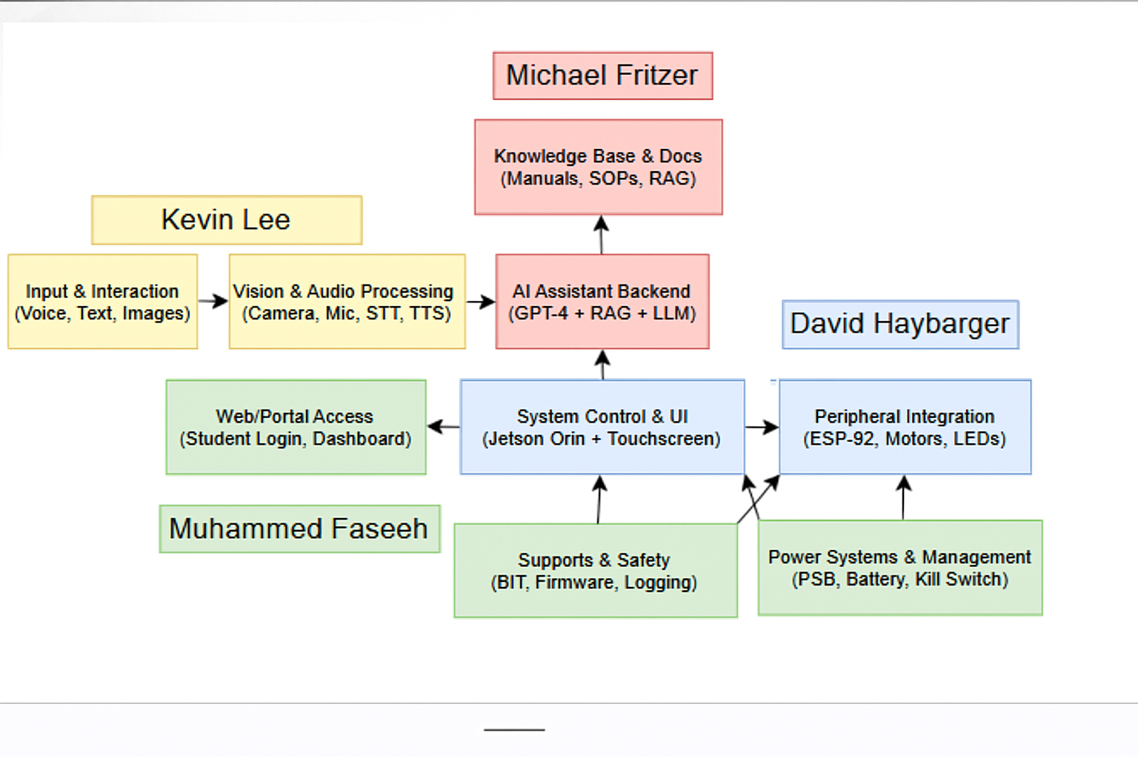
Figure 2: Organized operational flow diagram for the AURA system

Referenced Documents and Standards
[1] “Jetson-Orin-datasheet-Nano-developer-kit-3575392-R2.PDF,” NVIDIA Corporation, Jetson Orin Nano Developer Kit Technical Datasheet,
https://nvdam.widen.net/s/zkfqjmtds2/jetson-orin-datasheet-nano-developer-kit-3575392-r2
[2] “ESP32 Series Technical Reference Manual,” Espressif Systems,
https://www.espressif.com/sites/default/files/documentation/esp32_technical_reference_manual_en.pdf
[3] “OpenAI GPT Model Technical Overview,” OpenAI Documentation,
https://platform.openai.com/docs/guides
[4] “IEC 61508 Functional Safety Standard,” International Electrotechnical Commission.
[5] “IEEE Standard 1474 for Intelligent System Architecture,” Institute of Electrical and Electronics Engineers.
[6] “Whisper Speech Recognition System Documentation,” OpenAI,
https://github.com/openai/whisper
[7] “AURA System Architecture and Flowchart,” Internal Project Document (Team 3), Texas A&M University.
[8] “AURA Software Repository,” GitHub Source Code Archive,
https://github.com/Mikester58/GPT-NLP-Lab-Assistant
[9] “Course Laboratory Manuals and Standard Operating Procedures,” Internal Academic Reference Set, Texas A&M University.
[10] “INR18650 P26A V2 Battery Cell Datasheet,” Molicel,
https://www.molicel.com/wp-content/uploads/INR18650P26A-V2-80087.pdf

Operating Concept

Scope
This project involves the design and development of AURA, a physical AI powered lab assistant built on the Jetson Orin Nano 2020 board. The system is designed to support laboratory environments by answering technical questions through natural language interaction, recognizing lab components through visual and audio input, and interpreting image based data such as circuit photographs or diagrams. AURA provides context aware support for students and instructors and functions as an augmentation to traditional TA roles.
Scope Includes:
• Voice based question and answer using a locally run language model
• Vision based recognition for identifying components and reading values
• Touchscreen interface with USB file handling and document viewing
• Logging of user interactions for analytics and instructor review
• Deployment of speech to text, text to speech, and camera processing on the Jetson Orin Nano
Limitations:
• No autonomous navigation or robotic manipulation
• Internet connection required for full GPT functionality
• Limited physical interaction, functioning as a stationary smart assistant
• File parsing restricted to supported formats

Operational Description and Constraints
AURA operates as an intelligent lab assistant positioned on a lab bench or workstation. When activated through either the touchscreen or the wake phrase “Hey AURA,” the system begins an interaction session that can include voice queries, visual inputs through the camera, or document uploads through the USB interface. The Jetson Orin Nano processes these inputs using the integrated language model and vision tools, and the system provides responses through speech and on screen output. After the session ends due to inactivity, user acknowledgment, or powering down, the interaction is stored in the logging system and uploaded to a central database for instructor review.
Constraints include:
• A stable internet connection is required for full GPT functionality and remote logging.
• Ambient noise in the laboratory may reduce wake word accuracy or affect speech to text performance.
• File parsing is limited to supported formats such as PDF, PNG, and JPG.
• Power consumption must be managed carefully due to the Jetson Orin’s processing demands and thermal output.

System Description
AURA is built around the Jetson Orin Nano 2020 board, which serves as the central computing platform for all language processing, vision tasks, and system coordination. The system integrates several major subsystems that work together to provide real time assistance in the laboratory environment.
AI Assistant Backend
The AI subsystem uses GPT based language models through the OpenAI API and is prompt engineered for laboratory specific question and answer tasks. It supports multimodal input including text, voice, and images. AURA also uses a retrieval augmented generation approach to draw information from curated laboratory manuals, worksheets, and standard operating procedures.
Hardware and User Interface Subsystem
AURA includes a touchscreen interface mounted to the Jetson Orin Nano that allows users to browse files, adjust settings, and manage interactions. The device supports USB file uploads and maintains onboard storage for caching documents. The interface provides real time visual feedback such as resting facial expressions, alerts, and conversation status.
Vision and Audio Subsystems
AURA uses a camera connected to the Jetson Orin for image based analysis, object recognition, and detection of laboratory components. A microphone array captures voice input for wake word detection and speech to text processing. A text to speech engine provides spoken responses during interactions.
Robotic Integration Subsystem
An ESP32 microcontroller supports basic expressive motion through servo based gestures and optional motor driven animations. It can also accept GPIO inputs from peripheral devices such as LEDs, buttons, and small sensors to expand system behavior when needed. These capabilities allow limited physical feedback and positional adjustment while keeping AURA primarily focused on information support rather than manipulation.

Modes of Operations

Mode | Functionality
Idle Mode | Default resting state. Displays a passive expression on the screen and listens for the wake phrase “Hey AURA” or touchscreen interaction. Uses minimal system resources.
Interaction Mode | Active conversation session initiated by voice or file input. Supports voice queries, image analysis, and returns responses through speech or on screen text. The session ends after a period of inactivity, after a user acknowledgement, or when the conversation reaches its limit.
File Mode | Allows users to upload files such as PDFs, schematics, and images through USB. The touchscreen interface is used to view, delete, or manage uploaded content.
Settings Mode | Accessed through the touchscreen or command menu. Allows users to adjust voice options, change the displayed face or animations, modify volume, reset session logs, or activate the kill switch. Sensitive options are password protected.
Admin Mode | Used by instructors or TAs to update local documents, upload SOPs or safety sheets, manage the knowledge base, clear cached data, or view usage logs.
Developer Mode | Reserved for developers during testing, debugging, or configuration. Provides access to diagnostics, hardware logs, API keys, model parameters, and system health metrics. Accessible through SSH, serial interface, or secure UI commands.
Maintenance Mode | Used for software updates, log cleanup, sensor testing, and hardware calibration. Typically used outside of active lab sessions and may temporarily disable system functions.
Offline Mode | Indicates loss of internet connectivity. Disables GPT services but allows local file navigation, basic UI interaction, and limited support through the local LLM and document retrieval system.
Table 1: Modes of Operation for the AURA System

Users

User Group | Description
Students (Primary Users) | No training required. Can interact via voice or touchscreen. Upload files, ask questions, receive visual/audio feedback.
Instructors / TAs | Can update the knowledge base, add lab-specific documents, access logs, adjust settings. Moderate training recommended.
Developers /Maintainers | Hardware/software maintainers. Require familiarity with Jetson Linux, ESP-32, and system architecture.
Table 2: User Groups Supported by the AURA System
Users benefit from instant access to technical support, real-time visual diagnostics, and searchable conversation logs.

Support
Support for AURA is provided through multiple resources that assist users, instructors, and maintainers during operation. The on-device interface includes help menus, basic troubleshooting prompts, and error messages that guide users when the system detects issues such as missing files, microphone errors, or loss of internet connectivity. Session status indicators are displayed on the touchscreen to help users understand whether AURA is listening, processing, or idle.
Instructors and system maintainers can access additional support through the administrator menu, which provides logs, usage statistics, and diagnostic information. This interface helps identify recurring issues, verify document availability, and monitor system performance. Developers have access to deeper support through SSH, serial console tools, and system monitoring utilities on the Jetson platform. These tools are used for debugging, updating software, and performing maintenance during testing or deployment.
Support does not include remote repair services or physical hardware replacement. Users are expected to follow provided documentation for basic troubleshooting, and advanced issues are handled by the project development team.

Scenario(s)

Lab Safety and Equipment Setup
Overview:
An undergraduate student in an Electronics I lab is preparing to operate a bench power supply for the first time. The TA is busy, so the student asks AURA for guidance.
Steps:
- Student: “Hey AURA, how do I safely connect the bench power supply to my circuit?”
- AURA: “First, confirm the voltage requirements of your circuit. For today’s op amp lab, keep it under ±15V. Always turn the supply off before connecting wires.”
- The student holds the front panel up to the camera. AURA identifies the channel labels and highlights the correct terminals.
- AURA: “Connect red to +15V and black to ground. Make sure your circuit ground matches the supply ground.”
- The student completes the setup. AURA records the interaction with a timestamp for later review.

4.2. Assisting with Research Lab Documentation and Data Review
Overview:
A graduate researcher needs to retrieve previous testing data and summarize findings for an advisor.
Steps:
- Researcher: “Hey AURA, can you pull up last Tuesday’s circuit setup for the inverter tests?”
- AURA locates the document: “Found a file labeled ‘Inverter_Setup_Scan_09-09.pdf.’ Displaying it now.”
- Researcher: “What values were used for the gate resistor and load capacitance?”
- AURA extracts values from the document and reads them aloud.
- Researcher: “Summarize the three main issues reported that day.”
- AURA lists the documented issues.
- Researcher: “Save this session as ‘Advisor Summary.’”
- AURA confirms the log is saved and synced.

4.3. Preparing for a Lab Practical Exam
Overview:
A student practices configuring an inverting amplifier circuit using AURA as a study tool.
Steps:
- Student: “Hey AURA, quiz me on setting up an inverting amplifier.”
- AURA asks step by step practice questions.
- The student answers and receives corrective feedback.
- The student uploads a breadboard photo.
- AURA identifies an incorrect resistor placement and suggests the correct feedback path.
- AURA saves the session under “Op Amp Exam Practice.”

4.4. Checking Component Values Before Use
Overview:
A first year student needs help identifying a resistor value.
Steps:
- Student: “Hey AURA, what value is this resistor?”
- The student holds the resistor to the camera.
- AURA: “Brown, black, orange, gold. That is 10 kΩ with five percent tolerance.”
- Interaction is logged under “Component Identification.”

Analysis

Summary of Proposed Improvements
The AURA system introduces several improvements to the traditional laboratory environment:
• Reduces TA workload by handling routine student questions during lab sessions.
• Increases student access to help, especially in large or high volume courses.
• Provides multimodal support by allowing students to speak naturally, show hardware to the camera, or upload files for analysis.
• Logs interactions for transparency, grading support, and system refinement.
• Promotes self guided learning by giving students instant, repeatable, and non judgmental assistance.
• Acts as a virtual TA simulator for students practicing outside scheduled lab hours.

Disadvantages and Limitations
Despite its benefits, AURA has several known limitations:
• Internet dependence: GPT based responses require a stable network connection.
• No mobility: AURA cannot move between stations or physically interact with hardware.
• Vision constraints: Component recognition performance depends on lighting and image clarity.
• Possibility of AI misunderstandings: Ambiguous or unfamiliar questions may lead to incorrect or incomplete answers.
• Knowledge base maintenance: Instructors and developers must update documents and prompt configurations to ensure accuracy.

Alternatives

Alternative | Pros | Cons
More TAs | Human nuance, mobility, real time feedback | Budget limitations, scheduling constraints, human error
Traditional Help Desk (Docs and PDFs) | No hardware required, easy to distribute | Not interactive, relies on students searching manually
Static FAQ Chatbot (Web based) | Low compute requirement, minimal hardware | Cannot interpret images or audio, limited usefulness
Table 3: Table of Pros and Cons
Trade-off Summary:
AURA provides the strongest balance between automation and student engagement by integrating voice, visual, and text based interaction. The primary trade off is increased hardware complexity and dependence on external API services for full functionality.

Impact

5.4.1. Environmental Impact
• AURA operates with low energy consumption due to efficient hardware such as the Jetson Orin Nano and ESP32.
• Plastic components and enclosures can be manufactured from recycled materials.
• Reduces reliance on printed lab manuals, worksheets, and documentation.

5.4.2. Societal Impact
• Enhances accessibility for students with disabilities or those with limited English proficiency.
• Provides consistent guidance across all users, improving fairness in instructional environments.
• Supports scalability in large engineering programs with limited TA availability.

5.4.3. Ethical Considerations
• AI responses may contain errors or bias; outputs must be monitored for accuracy and appropriateness.
• All logged data must be anonymized and securely stored to protect student privacy.
• Over reliance on AURA may reduce student development of troubleshooting skills; system usage should be balanced with human instruction.

